XGBoost-Based Multi-Class Intrusion Detection for Software-Defined Networks Using the UNR-IDD Dataset

1st DR.B.Surendiran
Department of Computer Science and Engineering
National Institute of Technology Puducherry
Karaikkal, India
surendiran@nitpy.ac.in
2nd Muneeswaran G
Department of Computer Science and Engineering(Cyber Security)
Karpagam Academy of Higher Education
Coimbatore, India
munishwaran933@gmail.com
3rd Nisanth Noel A
Department of Computer Science and Engineering(Cyber Security)
Karpagam Academy of Higher Education
Coimbatore, India
Nisanthnoel05@gmail.com
4th Yogin K
Department of Computer Science and Engineering
Karpagam Academy of Higher Education
Coimbatore, India
yogink33@gmail.com

Abstract— This paper talks about a way to make networks safer using a kind of network setup called Software-Defined Networking. This type of networking gives you the ability to control the network from one point making it easier to manage.. It also makes the network easier to take advantage of. . Some old ways of finding attacks might not work well with the kinds of attacks. This paper shows a way to find attacks using a machine-learning method called XGBoost. The method uses a data set called UNR-IDD. The system does a steps like getting ready the data removing duplicates and making the data easier to work with. Then it uses XGBoost to classify the data. The system looks at parts of the network like how many packets are received how many are sent and other details. It puts the network traffic into six groups: TCP-SYN, PortScan, Overflow, Blackhole and Diversion. Testing showed that the system works well with a success rate of 88.24 percent. It does well with some types of traffic but still has trouble with one type called Overflow. This method shows that XGBoost can be useful for finding types of attacks in Software-Defined Networking. It also gives a base for making clearer security systems for networks, in the future.
Keywords— Software-Defined Networking, Intrusion Detection System, Machine Learning, XGBoost UNR-IDD, Network Security, Multi-Class Classification, SDN Attack Detection.
- INTRODUCTION
Software-Defined Networking (SDN) is a way to design networks. It splits the control part from the data part. This helps to manage network resources in a way and makes it easier to program. The central control makes the
network more flexible and easier to scale. It also helps to manage traffic.. The central setup has some problems. It can create security issues. If someone attacks the network resources the switches, the flow tables or the traffic it can mess up the network. So an Intrusion Detection System (IDS) is very important for checking SDN traffic and finding behavior.
Traditional systems for intrusion detection use known patterns and rules. They can find threats that are already known.. They may not work well for new or complicated attacks. Machine learning offers another way. It learns from network traffic data. Can classify traffic based on what it learns. This helps a lot in SDN environments where the network changes a lot.
SDN traffic has features that can be used to find bad activity. These features include things like the number of packets received the size of data received the packets sent, the size of data sent how long a port's active changes in traffic the load on the network the number of active flow entries how many packets are checked and how many packets match certain rules. The UNR-IDD dataset has data about network ports that can be used to study SDN attacks.
In this work an XGBoost-based system is suggested for detecting intrusions in SDN. This system uses the UNR-IDD dataset. Unlike methods that only tell if traffic is normal or an attack this system can find the exact type of traffic. It puts traffic into six groups: TCP-SYN, PortScan, Overflow, Blackhole and Diversion.
The way this system works includes cleaning the data removing duplicates turning categories into numbers changing the target labels changing the data into a format training the XGBoost model checking it and testing it. The model is tested using accuracy, precision, recall, F1-score and Macro-F1. The results show that the model gets 88.24% correct in tests. This shows it can work well for detecting types of intrusions in SDN.
The main things this work adds are: (1) a system that uses XGBoost to find intrusions, in SDN (2) preparing and changing the data from network ports and flow statistics (3) grouping traffic into five attack types and normal traffic and (4) testing the model with types of results.
- RELATED WORK
Software-Defined Networking (SDN) is getting a lot of attention from researchers because the architecture is centralized and programmable.. Splitting the control and data planes creates new security problems. These problems include things like traffic, resource exhaustion, scanning and attacks on network-flow management. Because of this people are looking into machine-learning-based Intrusion Detection Systems (IDSs) as a way to stay safe than the old rule-based security methods.
Old ways of detecting intrusions usually depend on set rules and signatures to find attacks. These old methods work well for threats we have seen before. They struggle when traffic patterns change or when a new attack shows up. Machine-learning techniques fix this problem. Machine-learning techniques learn how traffic looks by studying labeled or unlabeled network data and then use those patterns to spot behavior.
Many different machine-learning algorithms are used for network intrusion detection. These include Decision Trees, Random Forest, Support Vector Machines, Neural Networks and learning methods. I think tree-based algorithms are a fit for network datasets that use numbers like packet, byte, flow and port statistics. Random Forest works by putting decision trees together to make classification more stable. On the hand gradient-boosting algorithms build decision trees one after another to lower prediction errors.
The UNR-IDD dataset is a tool for SDN intrusion-detection research because the UNR-IDD dataset shows network behavior using network-port and flow-statistical info. The UNR-IDD dataset has details like received and transmitted packets, received and transmitted bytes, port duration, delta traffic statistics, load info, active flow entries and packet lookup statistics. These details help machine-learning models learn the difference between traffic and different types of attack behaviors.
New research on machine-learning-based IDS shows that ensemble models are very good at classifying network attacks. However a lot of studies only focus on classification. This means they only label traffic as either normal or malicious. I feel that binary classification does not give us information about what kind of attack is actually happening. Multi-class classification is very important for SDN security because knowing the attack category helps us pick the right way to respond.
In this project I use XGBoost to do -class SDN intrusion detection using the UNR-IDD dataset. Of just doing binary detection this system finds six different traffic categories: Normal TCP-SYN, PortScan, Overflow, Blackhole and Diversion. I also check how well the model works by looking at accuracy, precision, recall, F1-score and Macro-F1. Checking the performance, for each class is very important. It helps me see which attack categories are still hard for the classifier to catch and shows where we can improve in the future.
- PROBLEM STATEMENT
More people are using Software-Defined Networking (SDN) these days. Software-Defined Networking (SDN) makes it much easier to program networks and manage everything from one spot. It also helps move resources around when needed.. Having a central setup for Software-Defined Networking (SDN) creates new security risks. This setup makes the network a target for different kinds of bad activities. Old ways of finding intruders usually rely on set rules or known patterns. These old methods work okay for attacks we have seen before. They often fail to spot new or strange behaviors in the network.
Another big problem is that traffic in Software-Defined Networking (SDN) can hold different types of attacks. Most simple tools only say if traffic is "normal" or "an attack." This is not enough. If a tool only gives a yes or no answer network admins will not know what kind of attack is actually happening. Without knowing the type of attack it is very hard for network admins to decide how to fix the problem.
Because of this we really need a way to find threats. We need an intrusion detection system that uses machine learning to look at Software-Defined Networking (SDN) statistics and tell the difference between traffic and specific types of attacks. In this project I am working on an XGBoost-based classifier. This classifier will study network-port and flow-statistical features to sort Software-Defined Networking (SDN) traffic, into six groups: Normal TCP-SYN, PortScan, Overflow, Blackhole and Diversion.
- PROPOSED SOLUTION
I am building an XGBoost-based -class intrusion detection system for Software-Defined Networking (SDN). This system looks at network-port and flow-statistical features from the UNR-IDD dataset. The goal is to sort every bit of traffic into one of six groups: Normal TCP-SYN, PortScan, Overflow, Blackhole and Diversion.
The way this framework works follows these steps:
UNR-IDD Dataset → Preprocessing → Feature Encoding → XGBoost Classification → Evaluation → Attack Detection
A. Dataset Preparation
I split the UNR-IDD dataset into three parts: training, validation and testing. I use the training data to teach the XGBoost model. I use the validation data while I am building the XGBoost model. Finally I save the test data to check how well the XGBoost model actually performs at the end.
B. Data Preprocessing
I start by removing any duplicate records before I begin training. I take the Label column out to use as my target variable. All the other columns become the input features.
The dataset has some categories like Switch ID and Port Number. I use One-Hot Encoding to turn these categories into numbers. For the numerical network features I process them on their own. If any data is missing I use imputation to fix it during the preprocessing steps.
C. Target Encoding
I turn the six traffic classes into numbers using label encoding. This step is important because it lets the XGBoost classifier handle -class classification.
D. XGBoost Classification
I chose XGBoost as my machine-learning algorithm. The XGBoost model learns how SDN traffic statistics connect to attack classes.
For the XGBoost model I set the estimators to 300 and the maximum tree depth to 6. I also set the learning rate to 0.1 the subsampling to 0.8 and the column sampling to 0.8.
E. Multi-Class Attack Detection
Once the training is done the XGBoost model predicts one of these six classes:
- Normal
- TCP-SYN
- PortScan
- Overflow
- Blackhole
- Diversion
I think this is much better than a detector that only says if traffic is normal or an attack. This way the system gives more detail.
F. Performance Evaluation
I check how well the trained XGBoost model works by looking at:
- Accuracy
- Precision
- Recall
- F1-score
- Macro-F1
- Confusion Matrix
I also look at the results class, by class. This helps me see which attack types the XGBoost model catches easily and which ones I might need to work on more.

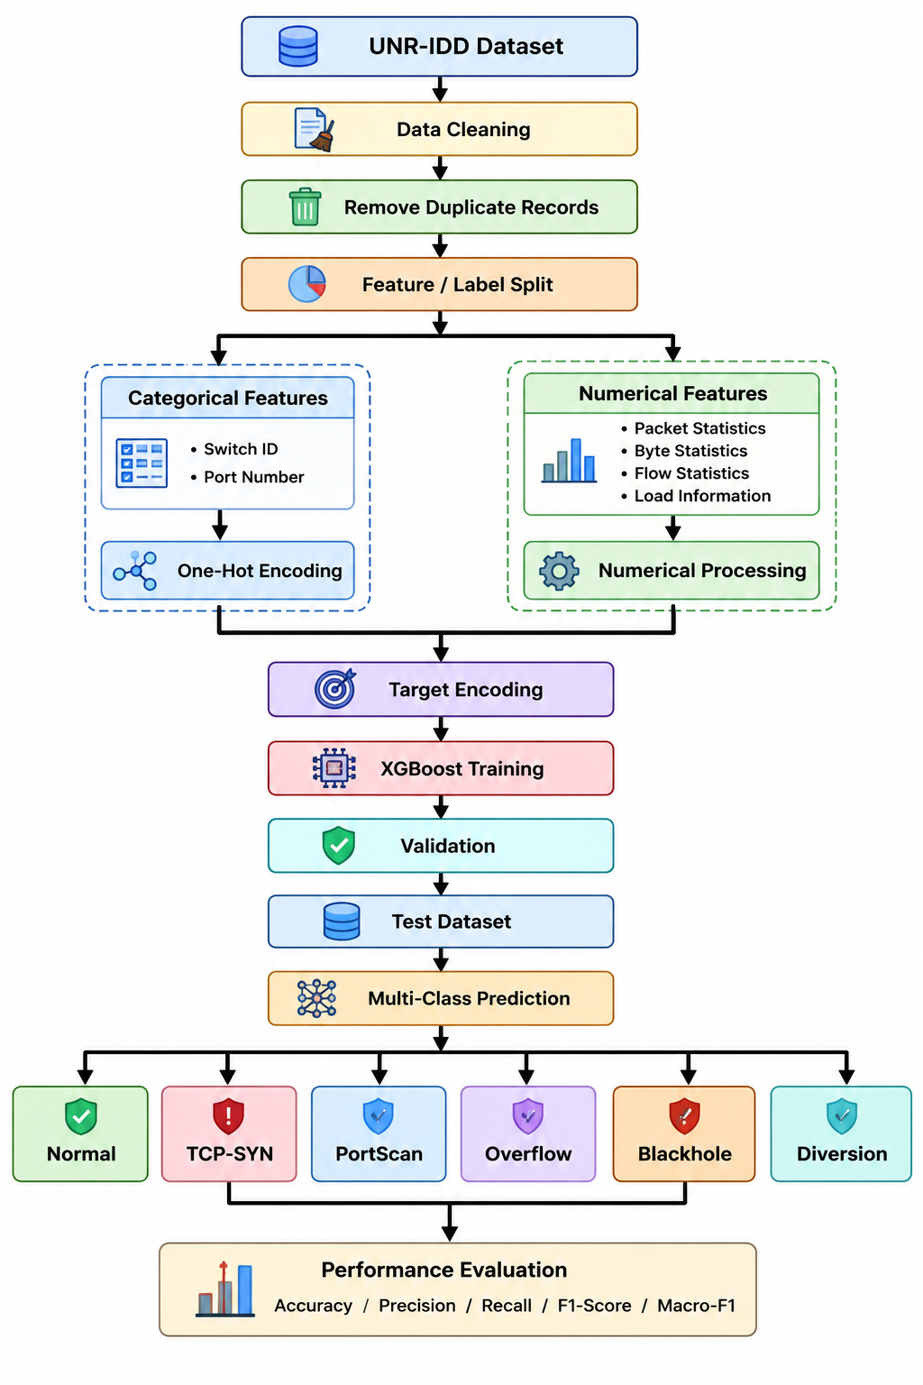
- DATASET DESCRIPTION
A. UNR-IDD Dataset
The proposed system has been implemented on UNR-IDD dataset. This particular dataset contains 22 columns. Out of these 22 columns there are 21 features serving as input and 1 column which acts as target label.
Features include switch and port number, packet information, byte numbers, flow details and information about load.
TABLE I. Features Used for SDN Intrusion Detection
Feature Category | Features
Identification | Switch ID, Port Number
Packet statistics | Received Packets, Sent Packets
Byte statistics | Received Bytes, Sent Bytes
Port activity | Port alive Duration (S), Delta Port alive Duration (S)
Delta statistics | Delta Received Packets, Delta Received Bytes, Delta Sent Bytes, Delta Sent Packets
Connection | Connection Point
Load | Total Load/Rate, Total Load/Latest
Unknown load | Unknown Load/Rate, Unknown Load/Latest
Byte counter | Latest bytes counter
Flow statistics | Active Flow Entries
Lookup statistics | Packets Looked Up, Packets Matched
Target | Label
Label column acts as the target variable where all other attributes are considered as features.
- ATTACK CLASSES
The classification problem therefore includes six classes, five attack classes.
TABLE II. Features Used for SDN Intrusion Detection
Class | Description
Normal | Legitimate network traffic
TCP-SYN | TCP SYN-based attack traffic
PortScan | Port scanning activity
Overflow | Overflow attack traffic
Blackhole | Blackhole attack traffic
Diversion | Diversion attack traffic
The goal of the classification problem is not to separate malicious traffic from legitimate traffic but also to identify the specific type of attack associated with the traffic.
- XGBOOST-BASED INTRUSION DETECTION
I decided to use Extreme Gradient Boosting (XGBoost) as the machine-learning tool for my SDN intrusion detection system. XGBoost is a way to build decision trees that works by adding many small trees one after another. Every new tree tries to fix the mistakes made by the trees that came before it. This helps XGBoost learn the messy links between SDN network features and different types of attacks.
In my system XGBoost takes in the preprocessed UNR-IDD features to sort data into six classes. These input features consist of packet statistics byte statistics, port-duration information load statistics, active flow entries, packet lookup statistics and other SDN network-port characteristics. I first use One-Hot Encoding to change things, like Switch ID and Port Number into a format the computer understands. I turn the target Label into simple numbers.
I set up the XGBoost classifier to use 300 estimators, a tree depth of 6 and a learning rate of 0.1. To make sure the XGBoost model works well on data I used a subsampling ratio of 0.8 and a column-sampling ratio of 0.8. I also set the XGBoost model to a -class objective so it can predict the six traffic categories: Normal TCP-SYN, PortScan, Overflow, Blackhole and Diversion.
TABLE III. XGBoost Model Parameters
Parameter | Value
Number of estimators | 300
Maximum depth | 6
Learning rate | 0.1
Subsample | 0.8
Column sample by tree | 0.8
Objective | Multi-class
Evaluation metric | mlogloss
Random state | 42
We train the model using the training dataset. We use the validation dataset to check how the model is doing while we develop it. Once training is finished we use a test dataset to evaluate the model’s final performance. The XGBoost classifier produces a predicted class for every test sample.
Obj=L+Ω
The general XGBoost objective function looks like this: Obj = L + Ω. Here L is the training loss and Ω is the regularization term that keeps the model complexity in check. As boosting proceeds more decision trees are built to lower the errors of the existing ensemble.
We evaluate the proposed XGBoost model, with accuracy, precision, recall, F1‑score and Macro‑F1. We also create a confusion matrix to examine how the model behaves for each attack category. In this experiment the XGBoost model reached a test accuracy of 88.24% showing that it can separate SDN traffic from many attack types. Yet when we look at each class we see that some attacks, Overflow, are harder to catch and need more tuning.

- EXPERIMENTAL METHODOLOGY
The goal of this work is to create and check an XGBoost-based system that can detect types of attacks in Software-Defined Networking. This system uses the UNR-IDD dataset. The way the experiment is done includes getting the dataset ready cleaning the data changing the features training the model checking it testing it and seeing how well it works.
A. Getting the Dataset Ready
The UNR-IDD dataset is the data source for the system that detects attacks. The dataset has information about network ports and flow statistics that show how an SDN network behaves. In this project the dataset is split into three parts:
- train.csv – used to teach the model.
- val.csv – used to check the model as it learns.
- test.csv – used to see how well the model works at the end.
The dataset has 22 columns. These include 21 features that are used to make predictions and one label that shows what type of activity is happening. The label has six types: Tcp-SYN, PortScan, Overflow, Blackhole and Diversion.
B. Cleaning the Data
These steps are done before the model is trained.
1) Loading the Data:
The training, validation and testing datasets are brought in using the Pandas library.
2) Checking the Data:
The way the data is structured the types of features any information and how the different classes are spread out are looked at.
3) Removing Duplicates:
Any repeated records are taken out from the training, validation and test datasets. This helps to make sure the model is not biased by the data multiple times.
4) Separating Features and Labels:
The column, with the label is taken out as the target variable Y. All the other columns are used as the input features X.
5) Finding Out What Type of Features They Are:
The features are split into ones that're categorical and ones that are numerical. The Switch ID and Port Number are considered categorical. All the other network stats are considered numerical.
C. Changing the Features
1) Encoding Categorical Features:
One-Hot Encoding is used for the features. The encoder is made using the training data. Then used on the validation and test data.
2) Processing Numerical Features:
The numerical features are handled using imputation when needed. The numerical data is then put together with the encoded features.
3) Encoding the Target:
The six types of labels are turned into numbers using Label Encoding. These numbers are then given to the XGBoost model.
D. Training the Model
The cleaned training data and the encoded labels are used to teach the XGBoost model. The model is set up to handle six classes.
The main XGBoost settings used in the experiment are:
Table IV. Experimental Setup and Configuration
Parameter | Value
Number of estimators | 300
Maximum depth | 6
Learning rate | 0.1
Subsample | 0.8
Column sample by tree | 0.8
Objective | Multi-class
Evaluation metric | mlogloss
Random state | 42
E. Model Validation
After the XGBoost model is trained the Model Validation step checks the model with the validation dataset. The validation results help us see how the model behaves before the test is run.
F. Model Testing
The independent test dataset is used to measure the performance of the intrusion detection system. The trained XGBoost model assigns one of six classes to each test sample: Normal, TCP‑SYN, PortScan, Overflow, Blackhole and Diversion. The test dataset is not used while training the XGBoost model.
G. Performance Evaluation
The performance of the XGBoost classifier is measured with these metrics:
- Accuracy – measures the proportion of classified samples.
- Precision – measures how correct the predictions are.
- Recall – measures how well we identify samples belonging to each class.
- F1‑score – represents the average of precision and recall.
- Macro‑F1 – calculates the average F1‑score across all classes giving weight to each class.
- Confusion Matrix – shows, for each class how many predictions were wrong.

H. Experimental Workflow
The complete experimental procedure can be summarized as:
UNR‑IDD Dataset → Data Loading → Data Inspection → Duplicate Removal → Feature/Label Separation → Feature Type Identification → One‑Hot Encoding → Numerical Processing → Target Encoding → XGBoost Training → Validation → Test Evaluation → Performance Analysis.
This methodology gives a framework for evaluating XGBoost as a multi‑class intrusion detection model, for SDN network traffic.
- PERFORMANCE EVALUATION
I tested how well the new XGBoost-based SDN intrusion detection system works by using a test dataset. Because the XGBoost-based SDN intrusion detection system has to sort data into different groups I used several different ways to measure its success. I looked at Accuracy, precision, recall, F1-score and Macro-F1 to see how the model performs overall and for each group.
A. Accuracy
Accuracy shows how times the model was right out of all the samples it tested. You can calculate Accuracy like this:
Accuracy=TP+TN+FP+FN / TP+TN​
For this multi-class classification task Accuracy shows the percentage of test samples that the model put into the right category.
B. Precision
Precision tells us how many of the samples the model guessed for a class were actually correct:
Precision=TP+FP / TP​
If the Precision is high it means the model does not make many mistakes by calling something an attack when it is actually safe.
C. Recall
Recall shows how good the model is at finding all the samples that belong to a specific class:
Recall=TP+FN/TP​
I think Recall is very important for an intrusion detection system. If the Recall is low it means the system is missing attacks.
D. F1-Score
The F1-score is a mix of precision and recall. You can calculate the F1-score using this formula:
F1=2×Precision+Recall / Precision×Recall​
The F1-score is a way to get a balanced view when you care about both false alarms and missed attacks.
E. Macro-F1
Macro-F1 finds the F1-score for each of the six classes one by one. Then finds the average:
Macro-F1=N/1​i=1∑N​F1i​
In this case N is the total number of classes, which is N=6. I use Macro-F1 because it treats TCP-SYN, PortScan, Overflow, Blackhole and Diversion classes with the same level of importance.
F. Confusion Matrix
I used a confusion matrix to see how the model performs for each class. The rows show the real classes and the columns show what the model predicted. The numbers, on the show the correct guesses while the other numbers show where the model got confused.
G. Experimental Results
Here are the results that the current XGBoost implementation got when testing the dataset.
TABLE V. OVERALL XGBOOST PERFORMANCE
Metric | Performance
Accuracy | 88.24%
Weighted Precision | 88.80%
Weighted Recall | 88.24%
Weighted F1-Score | 88.11%
Macro-F1 | 86.25%
XGBoostClassifier achieved 88.24 percent accuracy on the test set. 88.80 percent weighted precision shows the classes the model predicted were correct. 88.24 percent weighted recall indicates the model was able to capture most of the real traffic samples. 88.11 percent weighted F1-measure shows we have a good balance of precision and recall.
The Macro-F1 score was 86.25 percent which is lower than the weighted F1-score of 88.11 percent. This variance indicates the XGBoost classifier does not perform equally across all six classes. We must analyze each class independently and look for areas of each attack that need improvement.
TABLE VI. CLASS-WISE XGBOOST DETECTION PERFORMANCE
Class | Precision | Recall | F1-Score
Normal | 100% | 100% | 100%
Blackhole | 95% | 92% | 93%
Diversion | 91% | 94% | 93%
PortScan | 77% | 89% | 83%
TCP-SYN | 87% | 82% | 84%
Overflow | 100% | 47% | 64%
Looking at the results I can see that Normal traffic performs the best. Normal traffic hits 100% for precision, recall and the F1-score. Blackhole and Diversion also do a job with their classification performance. On the hand PortScan and TCP-SYN only show moderate detection performance.
The Overflow class is definitely the part to get right. Even though the precision for the Overflow class is 100% the recall is 47%. This means the model misses a number of real Overflow samples. This specific result shows me why class-wise recall and Macro-F1 are so important when you are testing -class SDN intrusion detection systems.
In the end these experimental results show that XGBoost is good, at -class classification of SDN traffic. The results also point out attack categories that we should work on improving in future work.
- RESULTS AND DISCUSSION
I tested the XGBoost-based IDS on the test set of the UNR-IDD dataset. After training the XGBoost-based IDS with the cleaned SDN network- port and flow- statistical features, I ran a test for a six-category classification problem consisting of TCP-SYN, PortScan, Overflow, Blackhole, and Diversion attacks.
The XGBoost model achieved a testing accuracy of 88.24%. I also noticed that weighted precision, weighted recall, and weighted F1-score were 88.80%, 88.24%, and 88.11%, respectively.
A Macro- F1 score of 86.25% implies that the XGBoost classification model performs decently but has varying levels of detection power when it comes to detecting each type of attack.
A. Overall Performance
TABLE VII. OVERALL XGBOOST PERFORMANCE
Metric | Performance
Accuracy | 88.24%
Precision | 88.80%
Recall | 88.24%
F1-Score | 88.11%
Macro-F1 | 86.25%
The accuracy of 88.24 percent shows that most of the test samples were classified correctly.
The precision of 88.80 percent proves that most samples that were put into a predicted class were in fact correct.
Likewise the recall of 88.24 percent tells us that the model was able to spot a share of the real traffic classes.The F1‑score of 88.11 percent reveals a balance between precision and recall.
However the lower Macro‑F1 score of 86.25 percent compared with the weighted F1‑score tells us that the model’s performance is not the same, for all six classes.
Therefore a class‑by‑class analysis is essential to see the strengths and limits of the proposed intrusion detection system.
B. Class-Wise Results
TABLE VIII. CLASS-WISE XGBOOST DETECTION PERFORMANCE
Class | Precision | Recall | F1-Score
Normal | 100% | 100% | 100%
Blackhole | 95% | 92% | 93%
Diversion | 91% | 94% | 93%
PortScan | 77% | 89% | 83%
TCP-SYN | 87% | 82% | 84%
Overflow | 100% | 47% | 64%
The Normal class shows the performance scoring 100% precision, 100% recall and 100% F1‑score. These numbers show that the model can clearly separate traffic from malicious traffic.
The Blackhole and Diversion classes also perform well each achieving an F1‑score of 93%. Their recall rates, 92% for Blackhole and 94% for Diversion show that the model can find samples in these attack groups.
The PortScan class scores an 83% F1‑score and an 89% recall. This means that most PortScan samples are found. A few are mislabelled as other classes.
The TCP‑SYN class has an 84% F1‑score with 87% precision and 82% recall. These figures show that the model can spot TCP‑SYN attacks well yet some attack samples still get mislabelled.
The Overflow class is the challenge for the proposed model. Even though its precision is 100% its recall falls to 47% giving it a 64% F1‑score. This tells us that when the model says a packet is Overflow the model is usually right but many real Overflow packets are being tagged as traffic.
C. Discussion
The results show that XGBoost works well for multi‑class SDN intrusion detection when using network‑port and flow‑statistical features. The model does well on the Normal, Blackhole and Diversion classes proving that these features hold good information for telling these traffic patterns apart.
The low recall of Overflow tells us that overall accuracy is not enough to judge an intrusion detection system. Missing attack samples can be more dangerous than a slight drop in overall accuracy. Therefore we should look at class‑wise recall and Macro‑F1 when judging how good the proposed system really is.
The gap between the F1‑score of 88.11% and the Macro‑F1 of 86.25% shows that the model behaves differently on the six classes. Making the detection of classes especially Overflow, better is a key goal for future work.
Overall the experiments show that the proposed XGBoost approach is a machine‑learning solution, for multi‑class SDN intrusion detection. The approach also highlights attack categories that still need more tuning.
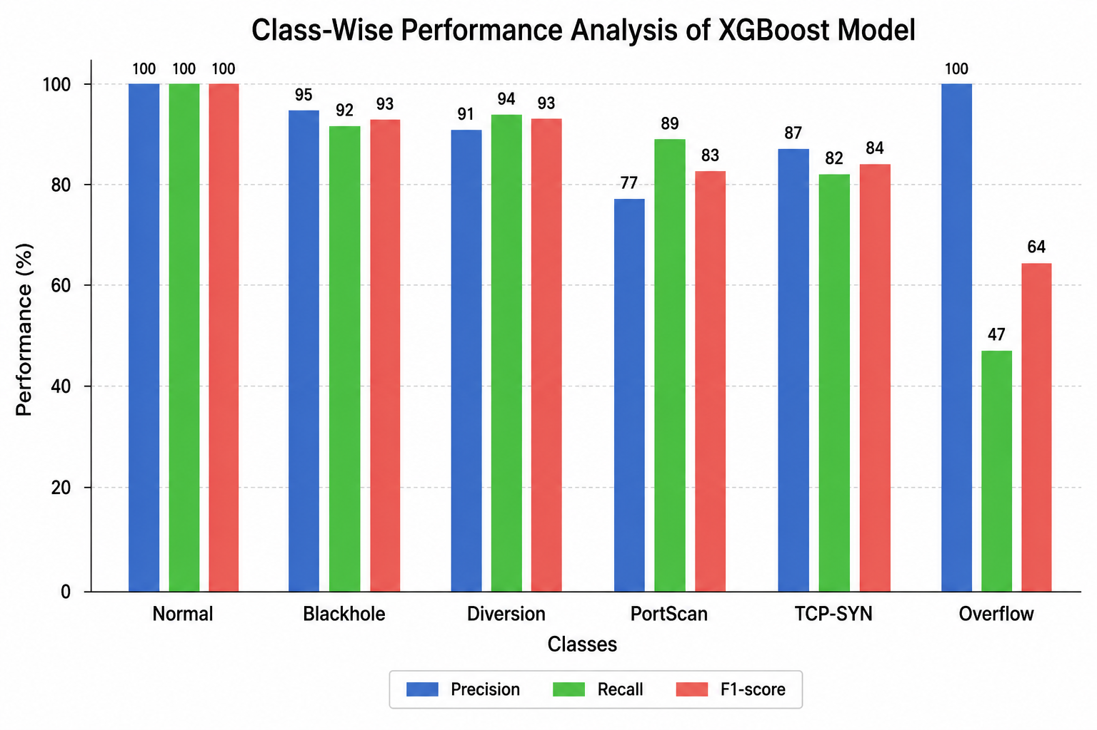
- CONFUSION MATRIX ANALYSIS
I used a confusion matrix to see how well the XGBoost-based intrusion detection system actually works for each type of traffic. This confusion matrix compares the traffic classes against what the XGBoost model thinks they are. In my experiment I looked at six classes: Normal TCP-SYN, PortScan, Overflow, Blackhole and Diversion.
In this confusion matrix the rows show the real classes and the columns show the classes the model predicted. The numbers on the diagonal line show where the model got things right. The numbers that are not on the show where the model made mistakes.
The confusion matrix gives me a look at how well the model tells different SDN traffic categories apart. I noticed that the model is very good at spotting the class. This tells me the XGBoost-based intrusion detection system can tell the difference between traffic and bad traffic quite well. The Blackhole and Diversion classes also performed well in the confusion matrix.
However the confusion matrix also shows me that the Overflow class is a problem. The recall for the Overflow class is 47%. This means the model misses a lot of Overflow samples and calls them something else instead. Even though the precision for the Overflow class is high the low recall means the XGBoost-based intrusion detection system is not catching every Overflow attack.
I also saw some mistakes with the PortScan and TCP-SYN classes. The recall for PortScan is 89%. The recall, for TCP-SYN is 82%. These mistakes happen because some attack traffic looks a lot like types of attacks.
In the end the confusion matrix tells a better story than just looking at a single accuracy number. The confusion matrix helps me see exactly which attack classes I need to fix. It really shows the parts and the weak parts of my XGBoost-based intrusion detection system.
Fig. X. Confusion Matrix of the XGBoost-Based SDN Intrusion Detection System.
- FEATURE IMPORTANCE ANALYSIS
I performed a feature importance analysis to see which SDN network features actually help the XGBoost intrusion detection model make its predictions. Because the XGBoost intrusion detection model uses decision trees the XGBoost intrusion detection model can calculate an importance value for every feature based on how much that feature helps the trained ensemble.
In this analysis I looked at the network-port and flow-statistical features used during training. This includes things like packet statistics byte statistics, port-duration information load statistics, active flow entries, packet lookup statistics and other SDN traffic characteristics. For the features I used an encoding process for Switch ID and Port Number before giving them to the classifier.
I ranked the feature-importance values from highest to lowest so I could see the influential features clearly. A feature with an importance value has a big impact on how the XGBoost intrusion detection model makes decisions. On the hand features with low importance values do not affect the classification results very much.
Fig. X. Feature Importance of the XGBoost-Based SDN Intrusion Detection Model.
The feature importance analysis gives me a way to understand how this intrusion detection system works. It helps me figure out which SDN traffic characteristics are best for telling the difference, between traffic and TCP-SYN, PortScan, Overflow, Blackhole and Diversion attacks. This data will also be very helpful when I work on feature-selection and model-optimization in the future.
Also this analysis helps network administrators understand what different traffic behaviors look like. For instance looking at packet counts byte statistics flow entries and packet lookup statistics can show how network activity changes when an attack happens. I believe the feature importance analysis works alongside classification metrics and confusion-matrix analysis because it shows exactly which input features drive the predictions of the XGBoost intrusion detection model.
Note: The exact ranking of the important features should be taken from the feature_importance.csv generated by your final XGBoost run rather than being assumed in the paper
- LIMITATIONS
The XGBoost-based SDN intrusion detection system that is being proposed shows results; however there are some things that need to be improved. First the testing was done using the UNR-IDD dataset. So the results might not fully show how the model works in all real-world SDN environments.
Second the system uses the XGBoost hyperparameters every time. Even though the model gets 88.24% accuracy changing those hyperparameters could make the model better at classifying things.
Third the model works better for some types of attacks than others. For example it only detects 47% of the Overflow attacks. This is a problem for an intrusion detection system because if it misses attacks it could harm network security.
Fourth the current system checks for intrusions after the data is already collected. It has not been connected to a SDN controller or network switches to watch traffic in real time and stop attacks as they happen.
Finally the way the model shows which features are important gives some information. It does not explain why the model makes certain predictions. Advanced methods, like SHAP-based analysis could help make the model easier to understand.
These issues give room for work like making hyperparameters better dealing with class imbalance picking better features making the model more explainable adding real-time SDN support and testing, with more datasets.
- FUTURE WORK
Although the XGBoost-based SDN intrusion detection system that is proposed shows results there are several areas that can be looked into to make it better. These include making it more accurate, more reliable easier to understand and better suited for real-life use.
Hyperparameter Optimization: Better ways to choose the settings for XGBoost can be used. These ways include Grid Search, Random Search or Bayesian Optimization. This can make the system work better when it is classifying things.
Handling Class Imbalance: Some methods such as SMOTE, ADASYN or cost-sensitive learning can be tried. These methods can help the system find types of attacks better especially the Overflow attack.
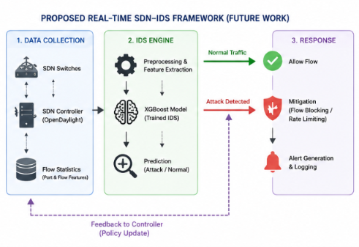
Real-Time SDN Deployment: The XGBoost model that is trained can be put together with an SDN controller. This can let the system check network traffic all the time and find attacks as they happen. The system can also be made to send warnings and take action automatically.
Evaluation Using Additional Datasets: More testing can be done with SDN and intrusion detection datasets. This can help see how well the model works in situations and with different kinds of attacks.
Feature Selection: Techniques that pick the useful features and make the system simpler can be used. This can make the model work faster. Possibly work better when it is classifying things.
Ai: Methods like SHAP and LIME can be added. These can help explain how the XGBoost model makes its decisions. This can help people understand the model better and trust it more.
Automated Attack Mitigation: Work in the future can make the system do more than just find attacks. It can also stop traffic limit how fast it goes send warnings and change the rules in the SDN controller.
Suggested figure:
Fig. X. Future research directions for the proposed XGBoost-based SDN intrusion detection system.
The figure above is good as a way to show work. It does not use numbers from experiments so it is better to use it in an IEEE paper than to use made-up graphs.
Important: For your IEEE paper do not use the earlier feature-importance or confusion-matrix image. That image had numbers that were not, from your data. Use your feature_importance.csv and confusion_matrix output for the pictures that show real experiments.
- CONCLUSION
This paper presents an XGBoost‑based multi‑class intrusion detection system for Software‑Defined Networking (SDN) that uses the UNR‑IDD dataset. The proposed method cleans SDN network‑port and flow‑statistical features. Applies categorical and target encoding before training the XGBoost classifier. The XGBoost system then classifies network traffic into six classes: Normal, TCP‑SYN, PortScan, Overflow, Blackhole and Diversion.
The experimental results show that the XGBoost model reached a test accuracy of 88.24 %. The weighted precision was 88.80 % weighted recall 88.24 % weighted 88.11 % and Macro‑F1 86.25 %. When looking at each class the XGBoost model detected Normal, Blackhole and Diversion traffic well while the XGBoost model also handled PortScan and TCP‑SYN traffic satisfactorily.
However the Overflow attack is still a challenge because the XGBoost model only recalled 47 % of those attacks. This means that more work is needed to catch Overflow attacks.
The confusion matrix and feature‑importance analysis give insight into how the XGBoost model behaves and which network characteristics the XGBoost model relies on.
Overall these results show that XGBoost is a tool for multi‑class SDN intrusion detection that uses network‑port statistics. Future work will focus on tuning the XGBoost hyperparameters handling class imbalance selecting features using AI techniques, like SHAP, testing on more datasets and integrating the XGBoost model with a real‑time SDN controller to detect and mitigate attacks automatically.

